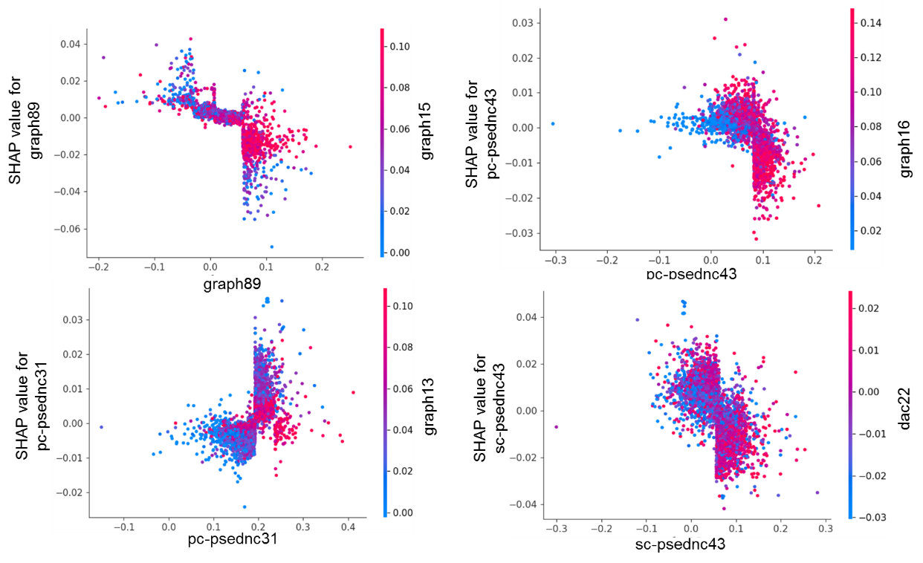

Figure S1. The SHAP dependence plots.